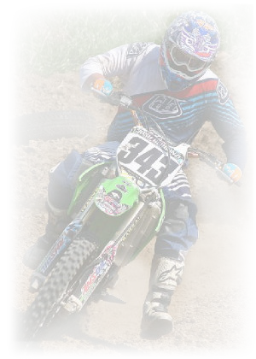 YANKTON SERIES MEMBERSHIP

YANKTON SCRAMBLERS CYCLE CLUB INC.

DATE: _______________

NAME: _____________________________________________________________

ADDRESS: __________________________________________________________

CITY:___________________________ STATE: ________ ZIP:_______________

HOME NUMBER: ________ - ________ - ________

CELL NUMBER: ________ - ________ - ________

EMAIL ADDRESS: ___________________________________________________

Please check which classes you would like to sign up for the Yankton Series. Each Class is $10.00. You have to race 4 out of our 6 race series to qualify for yearend.

Classes are as follows:

* PEE WEE B (4-6) 250 C
* PEE WEE A (7-8) 250 B
* PEE WEE OPEN 250 A
* 65 JR (7-9) 450 C
* 65 SR (7-11) 450 B
* 65 OPEN 450 A
* 85 JR (9-11) VET
* 85 SR (9-15) OUTLAW
* SUPER MINI WOMENS
* BEGINNER MINI ATV
* YOUTH ATV
* OPEN AMATEUR
* OTHER

# Classes _________ X $10.00 Per Class = $___________

Make Checks Payable to: **Yankton Scramblers Cycle Club**

**PO Box 266**

**Yankton, SD 57078**

Paid – Check #_________ Cash __________